
UNIVERSITY OF ASIA PACIFIC

COURSE CODE : CSE 212
COURSE TITLE : Database Systems Lab

Name of Project : Restaurant Management System

Submitted to
Nadeem Ahmed
Assistant professor, Dept. of CSE

Submitted by
Umme Salma Jui
Sararah Mahjabin
Reg. NO:- 18101051,18101067
Department Of CSE

Index

Topic | Page
1.Story | 03
2.ER Diagram | 04
3.Schema Diagram | 05
4.Appendix | 06-07
5.Data Insert | 08-15
6.Queries & Outputs | 16-24

Story

The objective of this project is to develop a database on Restaurant Management System. From this project and also by using this project we can get a clear idea about how the database works and how we can use this.

Our project Restaurant Management System is a computerized restaurant operation so that all information about customer’s orders, staff’s activity will be conveniently stored over and shared into the restaurant internet system. Staffs will be able to view the status with a click of a button. wait staffs will be able to enter into customers order in time and then have it electronically delivered to the kitchen and the kitchen staffs will be able to view the incoming orders and after that it delivered to the Admin as a final bill.

In this system, database all of the restaurant information is organized and saved for the management viewing

ER diagram

Password
Status
Payment ID
Name

Customer ID
Name
Menu ID
Email
register
Customer
Administration

Food ID
Admin ID

Start date
Contains
Food Name
Price
Menu ID
Price

End Date
Food ID
Quantity
Menu
Food Item
Item category
Job list
contains
Unit Price
Chef ID
Name
Quantity
Order ID
Chef

Order item

Order ID
User Name
Customer Choice
Quantity
Bill
Job to do

Payment Date
Payment ID
Quantity
Order Date
Payment
Customer ID
Payment type
Order
Order ID
Order ID
Pickup Date
Customer ID
Amount

Schema Diagram
Administration
Admin ID
Name
User Name
Password
Status
Menu ID

Menu
Menu ID
Price
Start Date
End Date
Food ID

Order Item
Order ID
Food ID
Quantity
Unit Price

Payment
Payment ID
Customer ID
Order ID
Payment date
Amount
Payment type

Food item
Food ID
Name
Quantity
Unit price
Item category

Order
Order ID
Order date
Customer ID
Quantity
Pickup date

Customer
Customer ID
Name
Email
Payment ID
Food ID
Chef
Chef ID
Name
Order ID
User name

Appendix
create database Restaurant

use Restaurant

create table Customer(
Customer_id varchar(30),
Customer_name varchar(30),
Email varchar(30),
Payment_id varchar(30),
Food_id int,
primary key (Customer_id),
);

create table Food_Item(
Food_id int,
Item_name varchar(30),
Quantity varchar(30),
Unit_price int,
Item_catagory varchar(30),
primary key (Food_id),
);

create table Order_Item(
Order_id varchar(20),
Food_id int,
Quantity varchar(30),
Unit_price int,
primary key (Order_id),
foreign key (Food_id) references Food_Item (Food_id)
);

create table OOrder(
Order_id varchar(20),
Order_date date,
Customer_id varchar(30),
Quantity varchar(30),
pickup_date date,
primary key (Order_id),
foreign key (Customer_id) references Customer(Customer_id),
);

create table Menu(
Menu_id int,
Price int,
Start_date date,
End_date date,
Food_id int,
primary key (Menu_id),
foreign key (Food_id) references Food_Item(Food_id),
);

create table Administration(
Admin_id varchar(20),
Name varchar(30),
Username varchar(30),
Password varchar(30),
Status varchar(30),
Menu_id int,
primary key (Admin_id),
foreign key (Menu_id) references Menu(Menu_id),
);

create table Chef(
Chef_id varchar(30),
Chef_name varchar(30),
Order_id varchar(20),
Username varchar(30),
primary key (Chef_id),
foreign key (Order_id) references OOrder(Order_id),
);

create table Payment(
Payment_id varchar(30),
Customer_id varchar(30),
Order_id varchar(20),
Payment_date date,
Amount int,
Payment_type varchar(30),
primary key (Payment_id),
foreign key (Order_id) references OOrder(Order_id),
);

Data insert

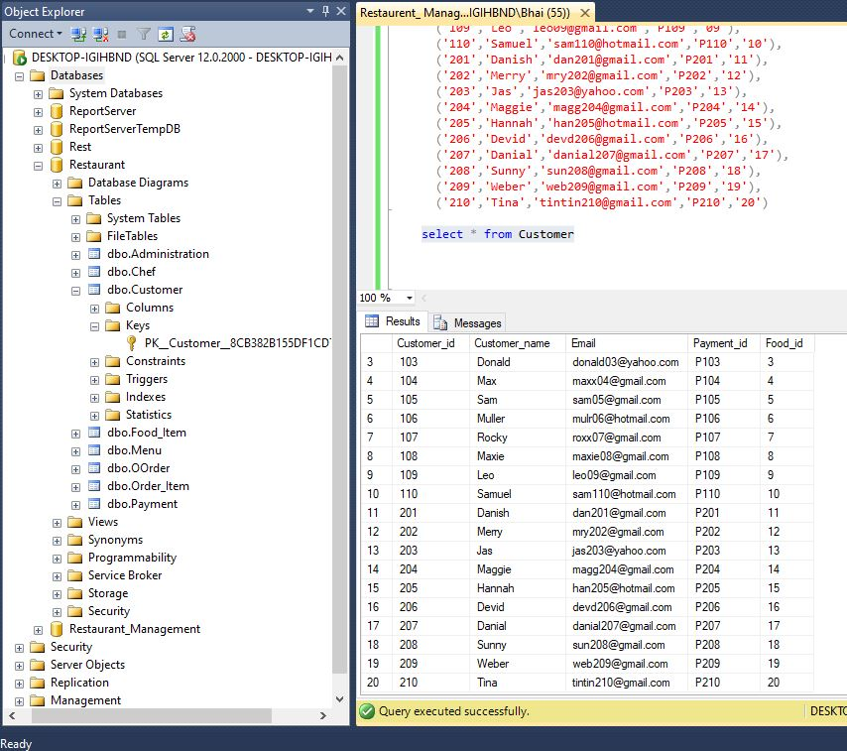

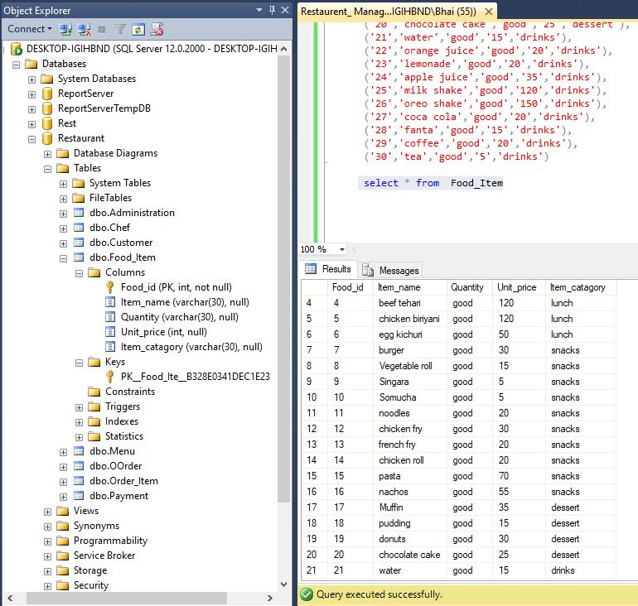

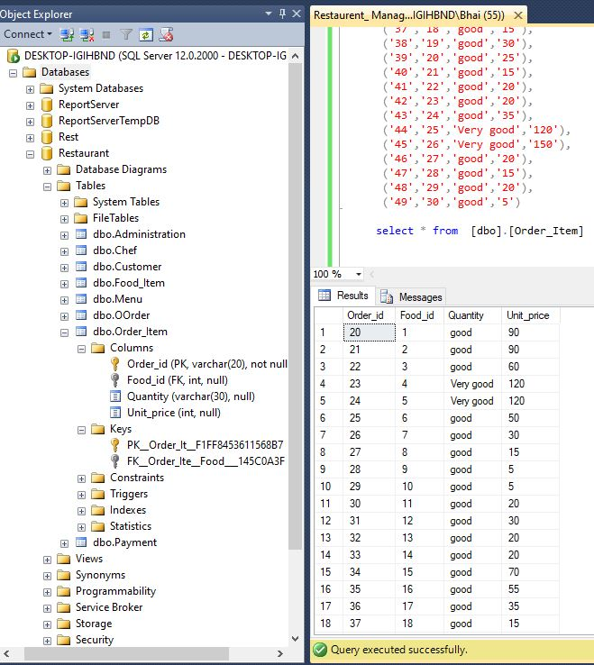

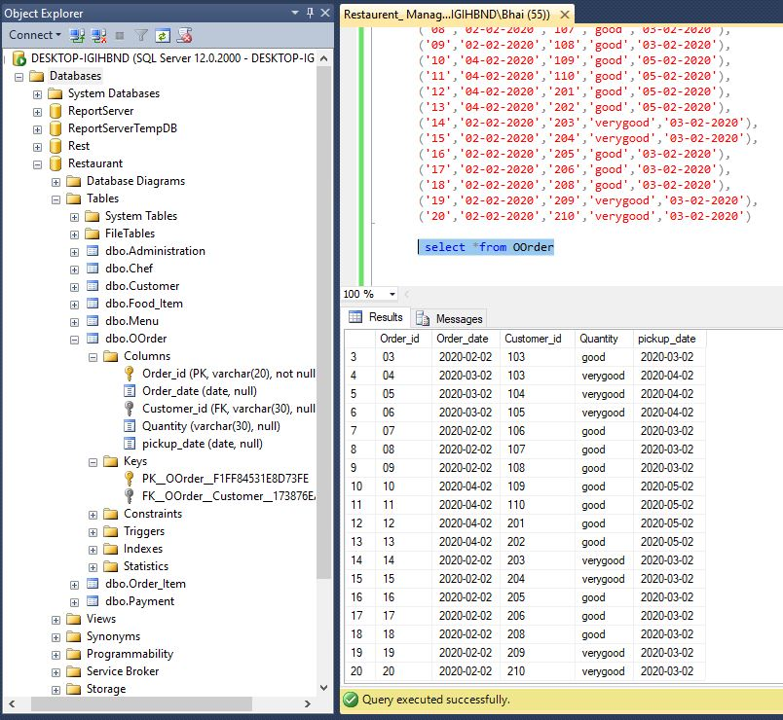

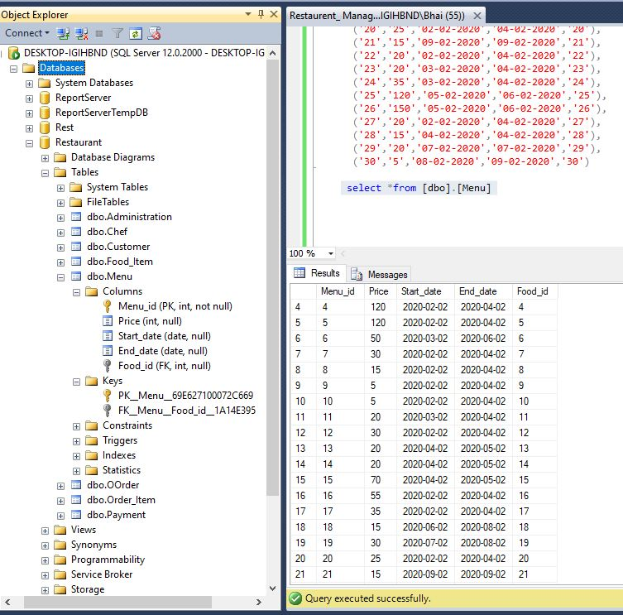

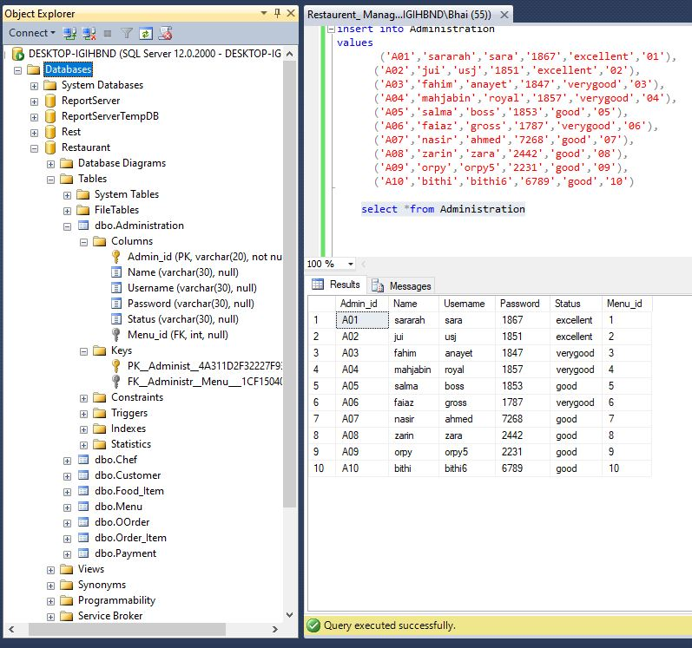

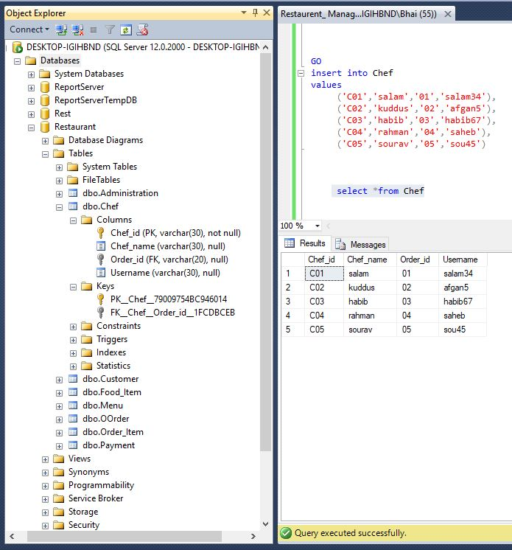

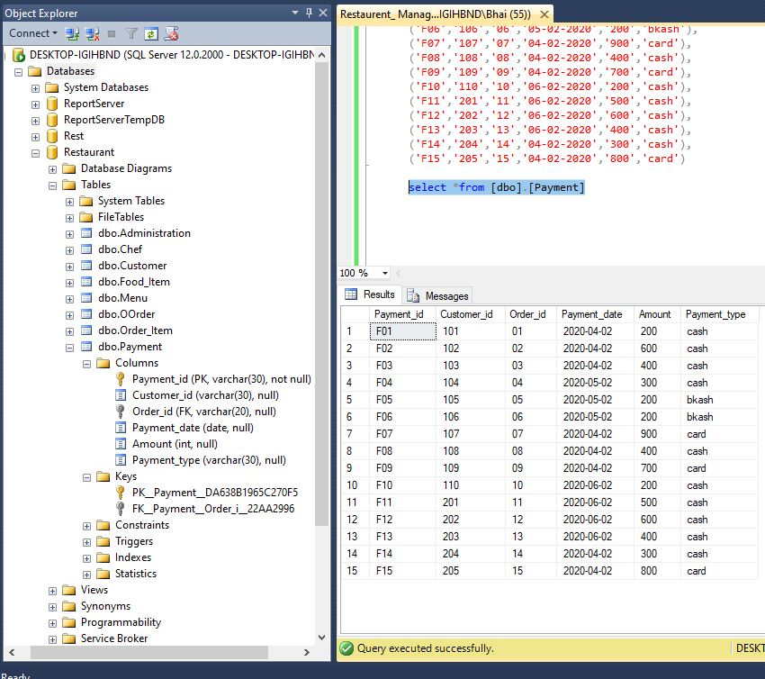

Queries & output

